**Introduction and Background**

Currently, there are the big problem in making schedule for class. Some academy still uses people to make the schedule. So the result is not good because people forgot much information of the resource. The information that people forget will make the schedule get the mistake by the people will forget the number of the room, number of the seat in each room, the available room and constrain of each teacher. From the making schedule problem there are so many place that use the human resource to making class schedule.

CAMT make the schedule by use staff and excel program to making the class schedule, and it have high complexity between the department and each year student in faculty. To making the class schedule should think about the many variable that can impact with another variable such as available time of each lecturer, available of each room. Often the class schedule of each department cannot merge the schedule together because the time to use the room or time of each lecturer have overlap.

There are many applications about manage or making the class schedule. Their application has some problems because the application did not support the environment of each place such as the number of the room, the seat in the room and the number of lab room. Another problem is the application cannot set the duration of each subject.

The goal of this application is to develop web application. The web application can help people reduce time and human resource because they make the class schedule easy than older. Finally, we hope that this application be useful for the staff in CAMT

**Business Review**

**Overview**

The class scheduling on website in a web application for personal computer, computer or smartphone that have web browser and use Web-Service to store and retrieve data from database. It is an application that helping users to making class schedule.

**Target**

The main target of this application is for class schedule in CAMT.They should have device that can connect with the internet and also have browser.

**Benefit**

1. Can use in many platform.
2. User can use this application in many environment.
3. Have data security.
4. Can develop in other platform.
5. Decrease maintenance cost.

**Business Tools/Software Review**

**GaSchedule**

This program is another one program class schedule management. The program scheduling by use file input which file input has the data configuration about the condition of scheduling. The program has to open configuration file and then choose create to make class schedule. After select generate create. Program will automatic generating schedule.

 .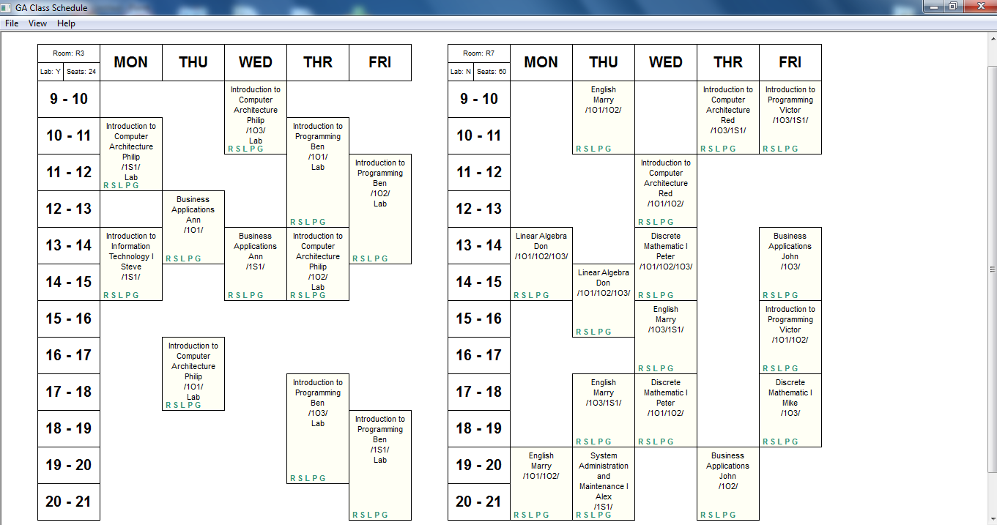

**Pro**

* Automatic generating schedule
* Easier to use it to generate schedule by open file configuration.

**Con**

* Is not convenient to create configuration file.
* The program can solve the problem only basic problem. Cannot solve more complexity.
* Cannot replace box in schedule if we want.
* Cannot manage in manual.

**ASCTimeTables**

This program is another one scheduling program which this program use strategy input each data configuration (such as teacher, subject, and classroom) to the program. The program can automatic and manual to create the schedule.

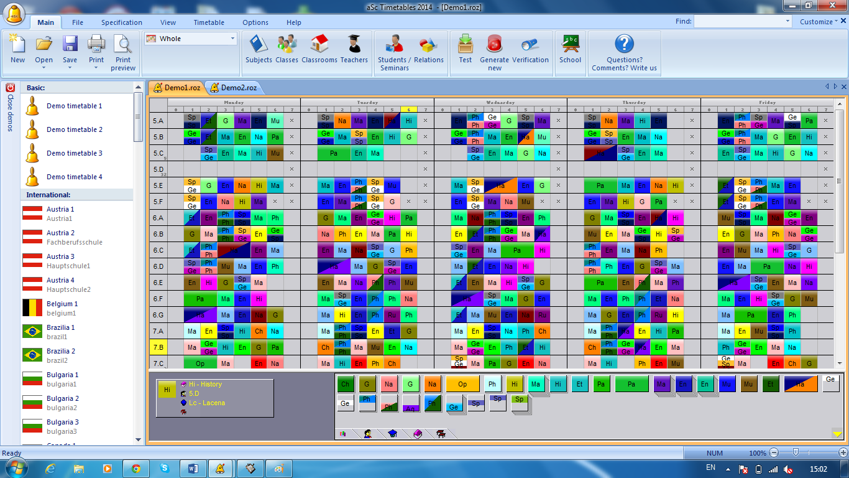

**Pro**

* Support with more condition
* Can scheduling more complex data
* Support any county
* Function rather completely

**Con**

* Difficult to see the detail
* Rarely orderly
* In schedule have detail not enough.

**Class schedule**

This program is another one scheduling program which this program use input data configuration (such as teacher, subject, and classroom) to the program. The program creates the schedule by manual. Use must to input any data which need to make a schedule into program and then select to create schedule. The data in schedule can edit data and can replace it.

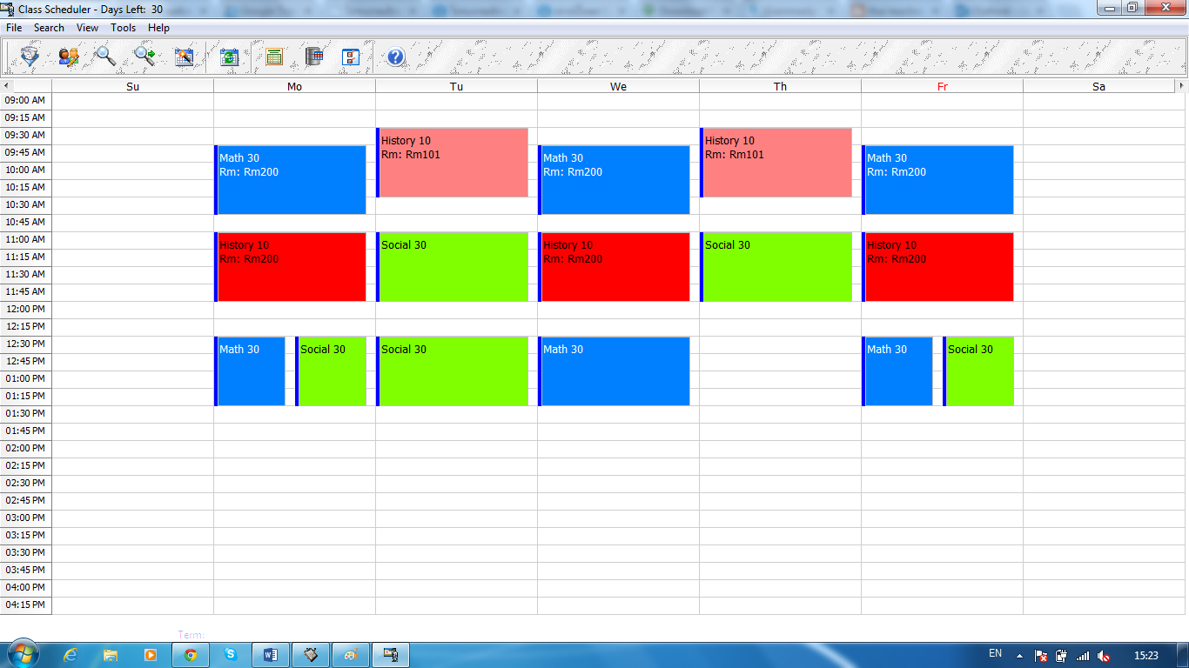

**Pro**

* Program have more function to use.
* Cover function that necessary
* Can manual edit

**Con**

* More complexity data.
* Difficult to use.
* Can manual edit but didn’t have guild line if cannot edit it.

**Technology Review**

**Web application**

Web application or web app is any application software that runs in a web browser.

**Alternative Technology**

No alternative technology for CSS

**The Selection of This Technology**

Nowadays the most people using website for open page or application that develop on website. For us, we choose web application because:

1. It is free
2. It can run the application on many environment.
3. it’s easy to access the application
4. Have many tools for us to develop

**PHP**

PHP is stand for Hypertext Preprocessor. It is an open source server-side scripting language to embed into HTML. PHP offers excellent connectively to many database including MySQL, Oracle, Sybase, Solid, Informix, PostgreSQL, Generic ODBC.

**Alternative Technology**

- ASP.NET

- JSP

- Perl

- Ruby

- Python

**The Selection of This Technology**

We chose PHP because, it supports our project in term of connecting between Android application and Web Service by using Soap created with PHP. It easy to find the solution that happens and easy to understand.

**CSS**

CSS is stand for Cascading Style Sheets. It defines how to display HTML elements. Styles are usually saved in external .css file. It gives comfortable to change the layout of all pages in web site.

**Alternative Technology**

No alternative technology for CSS

**The Selection of This Technology**

We chose CSS because; the CSS will be able to make our application look beautiful and easy to control.

**MySQL**

MySQL is a database management system and is a relational database management system. MySQL software is Open Source and is very fast, reliable, and easy to use. MySQL Server works in client/server or embedded systems. A large amount of contributed MySQL software is available.

**Alternative Technology**

* Microsoft SQL Server
* Sybase SQL Anywhere Studio
* Oracle
* Solid
* Point Base RDBMS.

**The Selection of This Technology**

We need MySQL to manage the information using database system. MySQL can support PHP we using. Since we search the benefit of MySQL on the internet, we found that many of the world’s largest and fastest growing organizations including Facebook, Google and Adobe rely on MySQL to save time and money powering their high volume Web sites, business-critical systems and packaged software.

**JavaScript**

JavaScript (JS) is an Open Source programing language commonly implemented as part of web browser in order to create enhanced user interface and dynamic websites.

JavaScript is prototyped-based scripting language that is dynamic, weekly typed and has first-class functions. It uses syntax influenced by the language C. JavaScript copies many names and naming conventions from Java, but the two languages are otherwise unrelated and have very different semantics. The key design principles within JavaScript are taken from the self and Schema programming languages. It is a multi-paradigm language, supporting object-oriented, imperative, and functional programming styles.

**Alternative Technology**

* Flash

**The Selection of this technology**

JavaScript will add user interactivity the special effects that are added to the web page will make it more interactive. The user/visitor of your website will want to keep exploring within the website.

If JavaScript is available, an initial validation of the website’s client can be done to check for simple errors such as missing information or non-numeric character mistakenly placed in a non-numeric field. As a result, the user of the website gets faster feedback than having to wait for a response from the server.

**Development Tools Review**

**Eclipse**

Eclipse is a community for individuals and organizations who wish to collaborate on commercially-friendly open source software. Its projects are focused on building an open development platform comprised of extensible frameworks, tools and runtimes for building, deploying and managing software across the lifecycle. The Eclipse Foundation is a not-for-profit, member supported corporation that hosts the Eclipse projects and helps cultivate both an open source community and an ecosystem of complementary products and services.

**Alternative Tools**

* Net Bean
* intellij idea

**The selection of this tool**

* Coverage in the IDE plug-in modules on the Net Bean platform.
* Working support with IDE using the new templates are created project and file by using wizard.
* Can determine the value of properties.
* Determine code which refers to the source editor

**Adobe Dreamweaver**

Adobe Dreamweaver is one of the most popular professional web development software packages. Dreamweaver is a complex product suitable for everything from simple page design to development of dynamic pages written with ColdFusion, PHP, ASP, CSS, XML, XSLT, and JavaScript.

**Alternative Tools**

* Microsoft FrontPage

**The selection of this tools**

Adobe Dreamweaver use to write and edit for web page that support HTML. We use Adobe Dreamweaver to develop the class schedule and also, we have a less experience to use another tools.

**Adobe Photoshop**

Adobe Photoshop is a graphics editing program developed. It uses color models RGB, lab, CMYK, grayscale, binary bitmap, and duotone. Photoshop has ability to read and write raster and vector image formats such as .ESP, .PNG, .GIF and .JPEG. Photoshop has ties with other Adobe software for media editing, animation, and authoring.

**Alternative tool**

* Adobe Illustrator
* PhotoScape

**The selection of this tool**

Adobe Photoshop is the industry standard in graphics editing: fillers the whole handling. It is convenient and easier to use and then also experienced age. Adobe illustrator is difficult to use and we have less experience to use Adobe illustrator. PhotoScape is easy to use but the picture that out from this program is not beautiful that we like.

**Quality Standard**

**ISO29110 for Very Small Entity (VSE)**

ISO29110 is a guide applies to a Very Small Entity (VSE), enterprise, organization, department or project up to 25 people, dedicated to software development. The Guide provides Project Management and Software Implementation processes which integrate practices based on the selection of ISO/IEC 12207- Systems and Software Engineering —Software Life Cycle Processes and ISO/IEC 15289Software Engineering – Software Life Cycle Process – guidelines for the content of software life cycle process information products (documentation) standards elements.

**Project Management process**

The purpose of the Project Management process is to establish and carry out in a systematic way the tasks of the software implementation project, which allows complying with the project’s objectives in the expected quality, time and cost. Selected process

* Project Planning Process
* Project Plan Execution Process
* Project Assessment and Control Process
* Project Closer Process

**Software Implementation process**

The purpose of the Software Implementation process is the systematic performance of the analysis, design, construction, integration and tests activities for new or modified software products according to the specified requirements. Selected process

* Software Implementation Initiation Process
* Software Requirements Analysis Process
* Software Architectural Design Process
* Software Construction Process
* Software Integration and Test Process
* Software Delivery Process

Chapter Four|

Project Plan

4.1 Motivation

Currently there are many class program application. Most of the program are generating a plan automatic by input configuration, which configuration use information are according with the condition that the program provided. Most programs cannot be used to manage the schedule for CAMT because the steps to create a table with multiple conditions in addition to calculated. It necessary thing is a manually configuration. So this application is the necessary thing to produce for solving problems.

4.2 Aims and Objectives

The aim of this project is to develop a web application that provides a way to connect centralized information. to help staff solve the problem during which their doing the schedule. To reduce the problem of scheduling overlap.

- Develop Web-service.

- The system should help staff to manage schedule

- Help staff by use centralized information

- To reduce the overlap of the data.

4.3 Deliverables and Limits

4.3.1Delivales

4.3.1.1Progress Report

* Log-in and log-out system
* Staff system.
* User interface all system